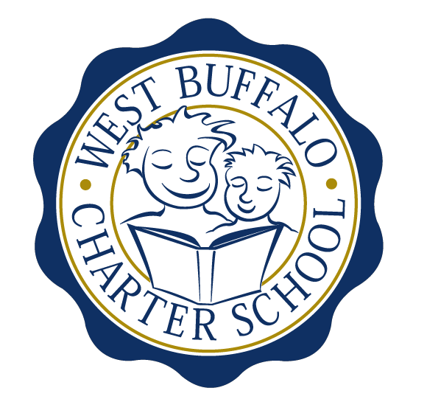

West Buffalo Charter School

Board of Trustees Meeting
November 28th, 2016
2:30 PM
D’Youville College, Bauer Family Academic Building, Room 105

Board Members
Present: Michelle Stevens, Lee Pearce, James Deuschle, Amy Friedman, Richard Baer
Excused: Arup Sen, James Sampson, Joanne Haefner
Quorum Present: Yes
Also Present: Andrea Todoro, Liz Sterns, Lynn Shea

Call to Order
Mrs. Stevens called the meeting to order at 2:26PM. Quorum present.

Proof of Public Notice of Meeting
Media and public announcement was sent on Monday, November 21st, 2016 to print, radio, and TV outlets announcing this open meeting. A posting was also sent to Erie County Hall, Buffalo City Hall and Buffalo City Court. In addition, it was publicly displayed at 50 East North Street and posted on the WBCS website. The Board of Trustees was duly notified of this meeting well within the timeline of our bylaws.

Monthly Meeting

Review of the September 26th, 2016 Meeting Minutes
Minutes of the September 26th, 2016 Board of Trustees meeting were presented for approval.

Upon motion duly made by Mr. Deuschle and seconded by Mrs. Pearce, the minutes of the September 26th, 2016 board meeting were approved as presented. All in favor. Non-opposed.

- Mrs. Sterns and Mr. Baer presented an expansion/construction update.
- Mrs. Sterns presented construction notes for Phase V.
- Mrs. Sterns will send out the RFP to the board for an electronic vote regarding Phase V.

Financial Report
Mrs. Sterns presented the financial reports for the periods ending September 30th and October 31st, 2016 (a copy is attached hereto and made a part hereof).

Upon motion duly made by Mr. Baer and seconded by Mr. Deuschle, the September and October, 2016 financial statements were approved as presented. All in favor. Non-opposed.

Upon motion duly made by Mrs. Friedman and seconded by Mrs. Pearce, the Catholic Charities contract was approved as presented. All in favor. Non-opposed.

Upon motion duly made by Mrs. Friedman and seconded by Mrs. Pearce, the International Institute contract was approved as presented. All in favor. Non-opposed.

Upon motion duly made by all attending board members, the 2016-2017 Safety Plan was approved as presented. All in favor. Non-opposed.

Upon motion duly made by Mr. Deuschle and seconded by Mr. Baer, the MOU with Cradle Beach (Living Classrooms) was approved as presented. All in favor. Non-opposed.

Upon motion duly made by Mr. Baer and seconded by Mr. Deuschle, the MOU with University Pediatric Dentistry was approved as presented. All in favor. Non-opposed.

School Leader Report

- Discussion regarding 2017 New York State testing changes to accommodations.
- A new Teaching Assistant will begin on December 5th, 2016.

Upon motion duly made by Mr. Deuschle and seconded by Mr. Baer, the appointment of one Teaching Assistant was approved as presented. All in favor. Non-opposed.

Upon motion duly made by Mr. Baer and seconded by Mr. Deuschle, the December calendar change was approved as presented. All in favor. Non-opposed.

- Mrs. Todoro presented AIMSweb, Fountas and Pinnell Data and New York State practice assessment data.
- Mrs. Todoro proposed to reactivate the board Data Committee. The committee will meet to analyze the data and report back to the Board of Trustees at a subsequent meeting.

New Business

- Mrs. Stevens formally welcomed new board member Amy Friedman and pending board member Lynn Shea to the WBCS Board of Trustees.

Adjournment
Being that there is no further business to discuss, a motion to dismiss was made by Mr. Deuschle and seconded by Mrs. Pearce. The meeting was adjourned 4:20 PM.

Respectfully submitted,
Leslie Bunis Ohl

The next WBCS board meeting will take place on Monday, December 19th, 2:30 PM at WBCS in Mrs. Todoro’s office.

